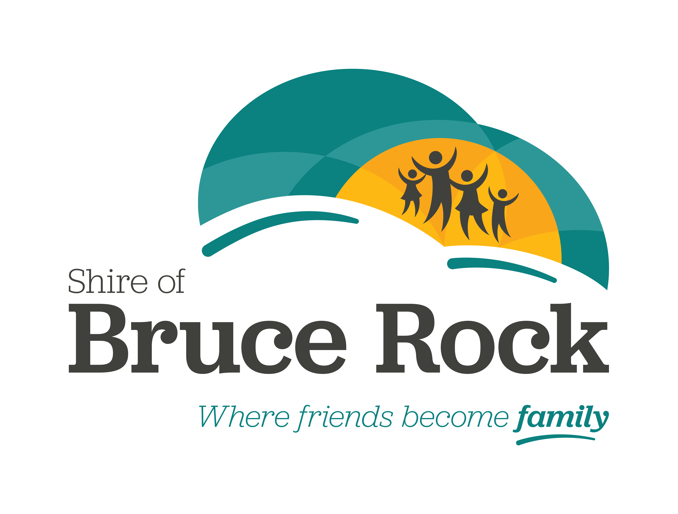

Annual Sports Awards

2024 NOMINATION FORM

The 2024 Shire of Bruce Rock Sports Awards consist of three categories: Sportsperson of the Year, Junior Sportsperson of the Year and Volunteer of the Year. Nominations will only be accepted on official nomination forms.

ELIGIBILITY: The Shire Bruce Rock Sports Awards are open to both men and women who are members of a Bruce Rock Sporting Club or Association, and who have shown excellent achievement in their chosen sport/s during the nomination year.

NOMINATION YEAR: The nomination year is 2024

WHO SHOULD NOMINATE: Nominations can be made by individuals, Clubs or Associations.

ENDORSEMENT OF NOMINATION: Club nominations are required to be endorsed by the relevant Club/Association Official (President/Vice-President/Secretary).

(Please tick appropriate box)

◻ Sportsperson of the Year Award
◻ Junior Sportsperson of the Year Award
◻ Volunteer of the Year Award

TO BE COMPLETED BY THE PERSON SUBMITTING THE NOMINATION

Your Name ________________________________________________________

EMAIL Address __________________________________________________________________

Telephone (Home) __________________ (Work) _________________________

Organisation Represented __________________________________________________________________

Your Club Position________________________________________________

Your Signature___________________________________________________

other people who may be contacted for further information on nominee

Person 1 NamE_____________________________________________________

EMAIL Address_____________________________________________________

tel (Home) __________________________(work) _________________________

Person 2 NamE ______________________________________________________

EMAIL Address______________________________________________________

tel (Home) _____________________________ (work) ______________________

DETAILS OF PERSON BEING NOMINATED

Name ______________________________________________________________

Telephone (Home) _________________________ (Work) __________________

OCCUPATION _______________________________________________________

DATE OF BIRTH ___________________________ (Age) _____________________

Achievements for which the person is being nominated:

___________________________________________________________________

___________________________________________________________________

___________________________________________________________________

___________________________________________________________________

___________________________________________________________________

___________________________________________________________________

___________________________________________________________________

___________________________________________________________________

___________________________________________________________________

___________________________________________________________________

___________________________________________________________________

___________________________________________________________________

___________________________________________________________________

___________________________________________________________________

Other significant achievements:

___________________________________________________________________

___________________________________________________________________

___________________________________________________________________

___________________________________________________________________

___________________________________________________________________

___________________________________________________________________

___________________________________________________________________

___________________________________________________________________

___________________________________________________________________

___________________________________________________________________

___________________________________________________________________

___________________________________________________________________

___________________________________________________________________

___________________________________________________________________

___________________________________________________________________

Please attach any further relevant information to the application.

Completed forms must be returned to:

2024 Sportsperson of the Year Award
Shire of Bruce Rock
PO Box 113, BRUCE ROCK WA 6418

OR

shayna.campbell@brucerock.wa.gov.au

