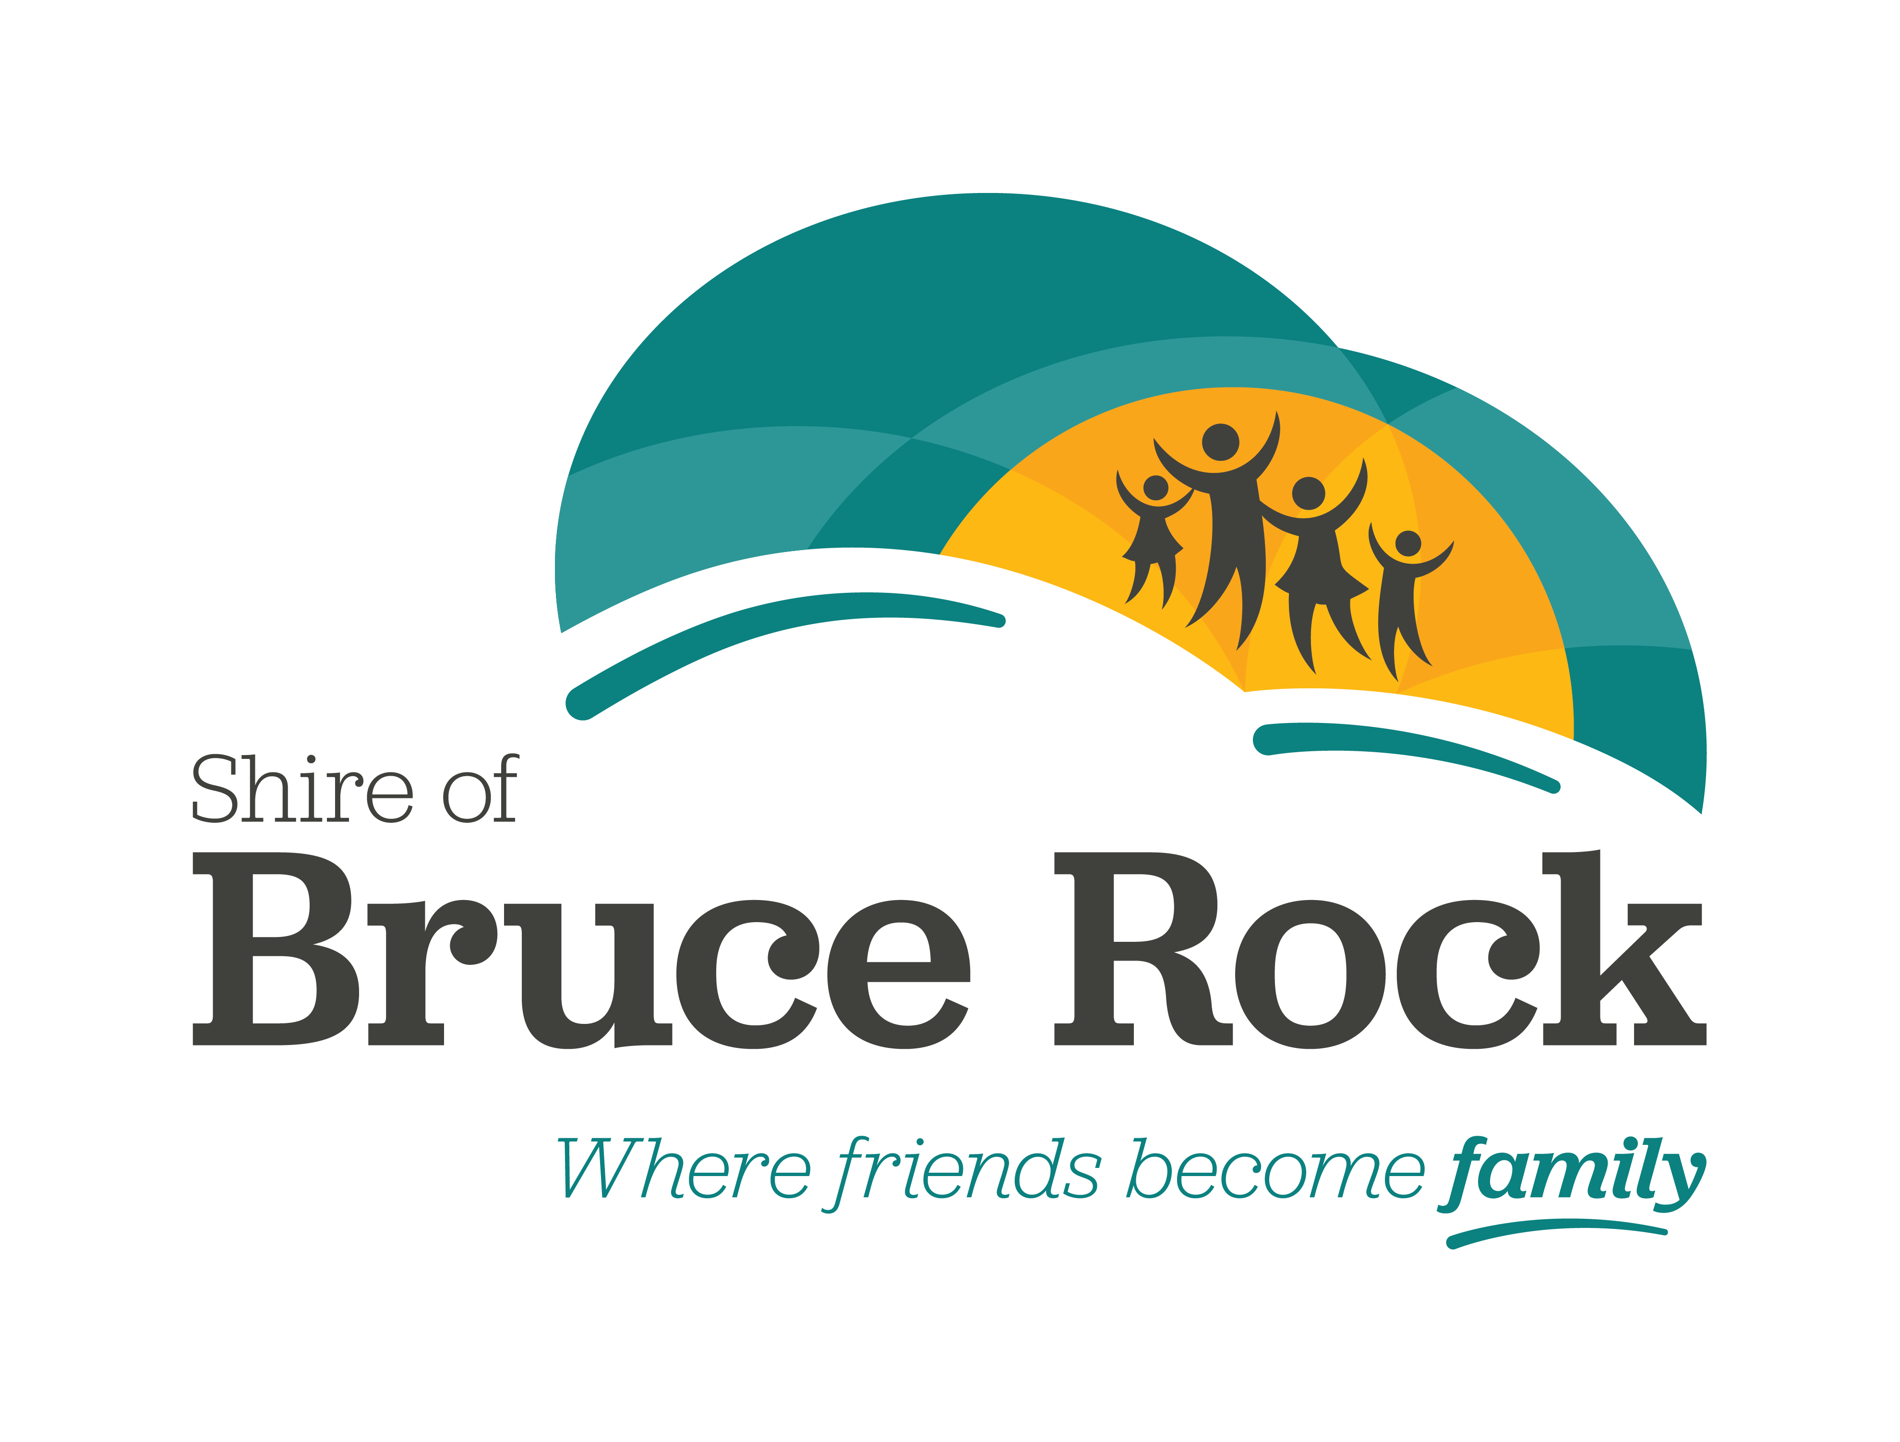

Volunteer of the Year Awards

2024 NOMINATION FORM

The 2024 Shire of Bruce Rock Volunteer Awards consist of three categories: Under 25, Adult and Community Group. Nominations will only be accepted on official nomination forms.

VOLUNTEER ACTIVITIES MAY HAVE BEEN UNDERTAKEN OVER NUMEROUS YEARS, AND DO NOT NEED TO BE LIMITED TO THE PAST 12 MONTHS.

Under 25 Volunteer of the Year Award
For individuals under the age of 25 who have contributed to an association, club, organisation or the community in an outstanding manner. Nominees do not necessarily need to be a member of a club, and may volunteer generally in the community.

Adult Volunteer of the Year Award
For individuals who are aged 25 and over, and who have contributed to an association, club, organisation or the community in an outstanding manner. Nominees do not necessarily need to be a member of a club, and may volunteer generally in the community.

Community Group Volunteer of the Year Award
For a community group, club or organisation that is not for profit and provides services and/or assistance to members of the community.

TO BE COMPLETED BY THE PERSON SUBMITTING THE NOMINATION

Please tick appropriate box:
◻ Under 25 Volunteer of the Year Award
◻ Adult Volunteer of the Year Award
◻ Community Group Volunteer of the Year Award

Your Name ________________________________________________________

Address __________________________________________________________________

TELEPHONE __________________ EMAIL _______________________________

Organisation Represented (if applicable)

other people who may be contacted for further information on nominee

Person 1 NamE_____________________________________________________

Address____________________________________________________________

tel (Home) __________________________ EMAIL _________________________

Person 2 NamE ______________________________________________________

Address____________________________________________________________

tel (Home) _____________________________ EMAIL ______________________

DETAILS OF PERSON BEING NOMINATED

Name ______________________________________________________________

ADDRESS ___________________________________________________________

tel (Home) __________________________ EMAIL _________________________

OCCUPATION _______________________________________________________

DATE OF BIRTH ___________________________ (Age) _____________________

REASONS for which the person is being nominated:

___________________________________________________________________

___________________________________________________________________

___________________________________________________________________

___________________________________________________________________

___________________________________________________________________

__________________________________________________________________

___________________________________________________________________

___________________________________________________________________

___________________________________________________________________

___________________________________________________________________

___________________________________________________________________

___________________________________________________________________

Any other relevant background details:
___________________________________________________________________

___________________________________________________________________

___________________________________________________________________

___________________________________________________________________

___________________________________________________________________

__________________________________________________________________

___________________________________________________________________

___________________________________________________________________

___________________________________________________________________

___________________________________________________________________

___________________________________________________________________

___________________________________________________________________

___________________________________________________________________

___________________________________________________________________

Please attach any further relevant information to the application.

Completed forms must be returned to:

2024 Volunteer of the Year Award
Shire of Bruce Rock
PO Box 113, BRUCE ROCK WA, 6418

or

shayna.campbell@brucerock.wa.gov.au

